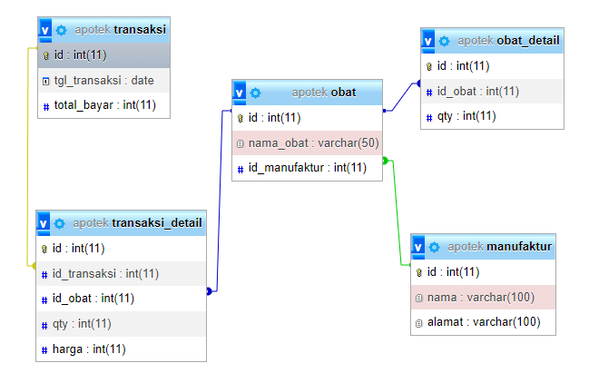

ALTER TABLE obat

ADD CONSTRAINT fk_manufaktur

FOREIGN KEY (id_manufaktur) REFERENCES manufaktur(id);

ALTER TABLE obat_detail

ADD CONSTRAINT fk_obatdetail

FOREIGN KEY (id_obat) REFERENCES obat(id);

ALTER TABLE transaksi_detail

ADD CONSTRAINT fk_transaksi

FOREIGN KEY (id_transaksi) REFERENCES transaksi(id);

ALTER TABLE transaksi_detail

ADD CONSTRAINT fk_obatt

FOREIGN KEY (id_obat) REFERENCES obat(id);